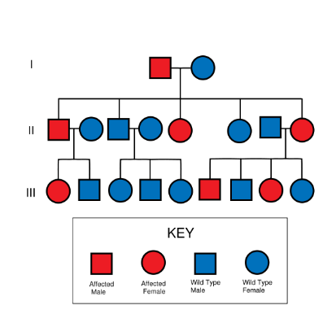
Name: ___________________________
Pedigrees

NAME _________________________

Part One

1. Go to the link on our class website: http://www.saburchill.com/IBbiology/chapters03/006.html

1. What is a pedigree chart?

2. Why do scientists use pedigree charts?

Symbols used in pedigree charts
3. Draw the symbol that represents a male.

4. Draw the symbol that represents a female.

5. What does a line in between two individuals represent?

6. How is an individual that is affected by the trait shown?

7. Describe how a pedigree chart differentiates between parents and offspring.

Organizing the pedigree chart
8. What is a generation? How many generations are depicted in the pedigree at the bottom of the page?

9. Look at the top pedigree. How many children does that couple have? What are the sexes of the children?

10. Look at the bottom pedigree. How many children does the original couple have? Are any of these children affected individuals? Explain.

11. In the bottom pedigree, in the fourth generation, list the sex of each child from oldest to youngest.

Part Two
1. Draw a pedigree chart for the following family. Charlie and Renee are grandparents. They have 3 children, Jessica, Crystal, and Gina. Jessica is married to Gale and they have a daughter named Rue. Crystal is married to John and they have 3 children, Alice, Mark, and Ian. Gina is divorced and has 2 daughters, Kate and Rose.

2. Draw a pedigree of your family. Show at least three generations.

