Name______________________
Virtual Cell Lab
Go to the following website:

http://tinyurl.com/4u7qwu

Follow the procedure listed on the left side of the page for both the animal cell and the plant cell. Then answer the following questions:

- How are cells similar to a factory or business? List three similarities.

- How are animal and plant cells similar? How are they different?

- A solar cell is a device that collects energy from the sun to make electricity. What part of a plant cell is most similar to a solar cell?

- Why is the nucleus considered to be the “boss” of the cell?

- Exploring the South American rain forest, a scientist discovers a mysterious organism and brings it back to the lab for further study. What cell characteristics should the scientist examine to tell whether the organism is an animal or plant? Why?

Virtual Pond Water

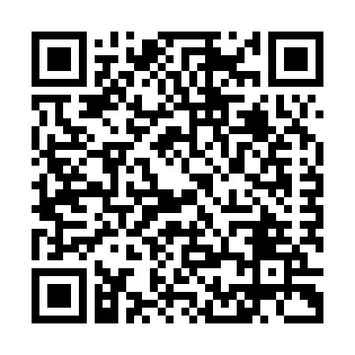
Directions:
Go to the website: Or Scan this QR Code:
http://tinyurl.com/7l2sm

This website shows various organisms commonly found in ponds, called protists. Click on 5 of them to learn more about each one. Use the information to complete the following table.
Name of Organism | Habitat (where to find them) | Size Range | How does it get food? | One interesting fact

Question:
Have you ever been swimming in a lake or pond and accidentally swallowed some water?
What are your thoughts on the possibility of having ingested some of these creatures?

